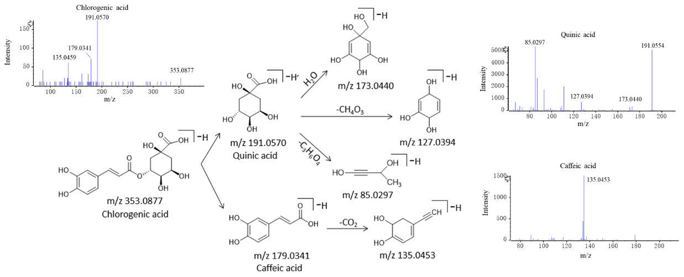
Additional file 2-1. The MS2 spectra and cleavage processes of chlorogenic acid

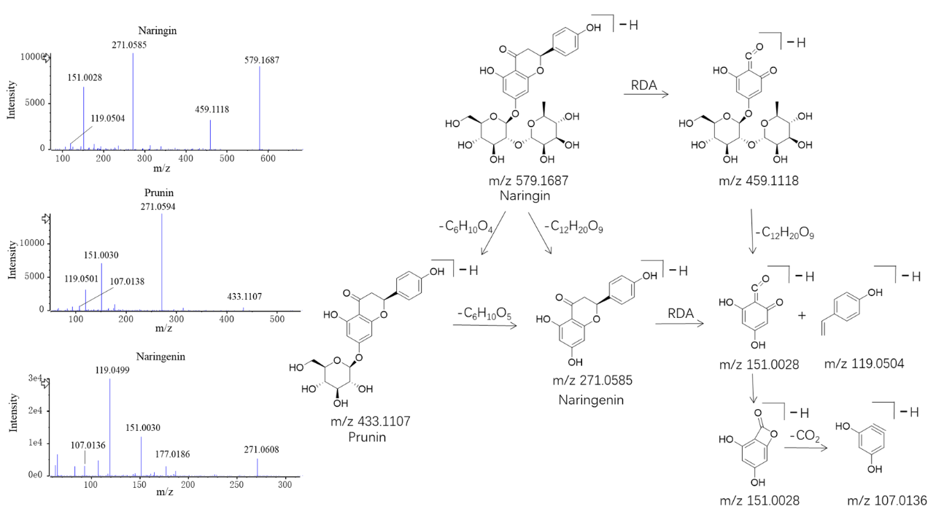
Additional file 2-2. The MS2 spectra and cleavage processes of naringin

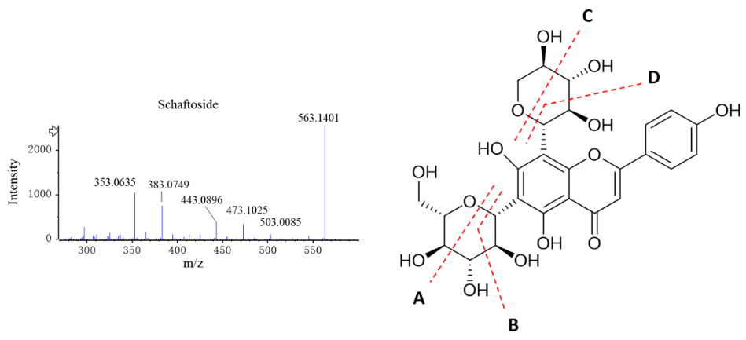
Additional file 2-3. The MS2 spectra and cleavage processes of flavone C-glycosides

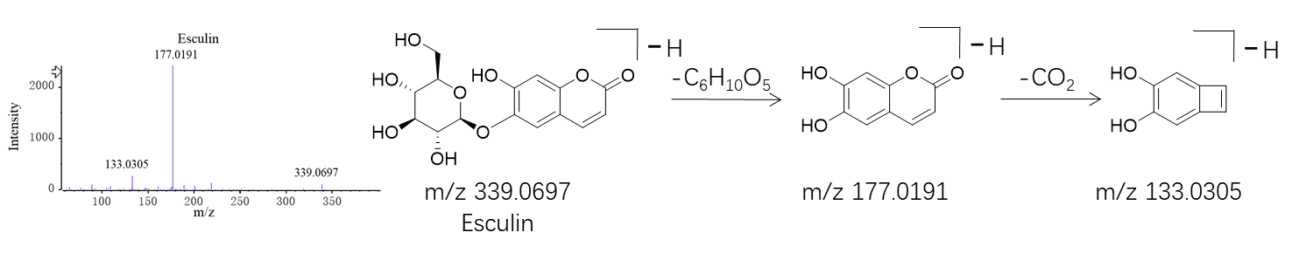
Additional file 2-4. The MS2 spectra and cleavage processes of esculin

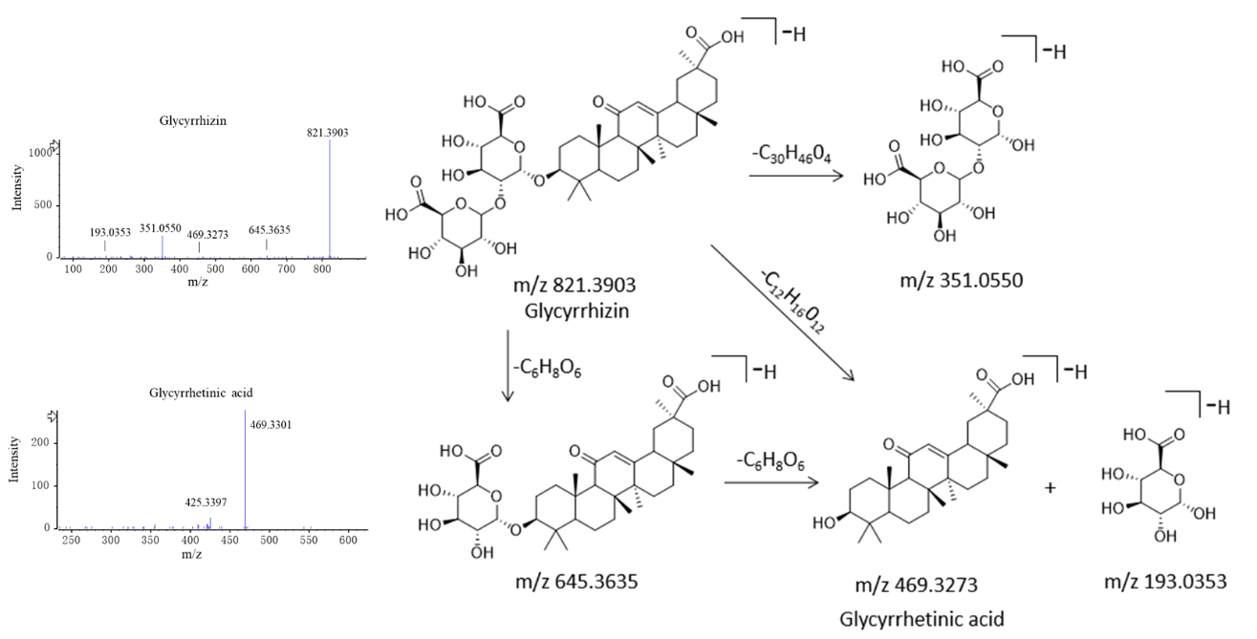
Additional file 2-5. The MS2 spectra and cleavage processes of glycyrrhizin

